**Document Scanner Using Opencv And GUI(Tkinter)**

Made by : Mohamed Eid, Amr Mohamed, Ahmed Nageh ,Gamal Ali

Supervised by: Dr. Ahmed Donkol, Eng. Ahmed Moaty

**ABSTRACT:**

Document Scanner application facilitates easy scanning, storage of photos and important documents online. The application uses python libraries to convert text and images as scanned document. The idea is to select a targeted portion of the document to be scanned and create a clear copy of that in image or pdf format. Hence this application will process the document in various available formats. Keywords: Scanner, document, conversion, text recognition, image to character.

**INTRODUCTION**

Doc scanner systems facilitate the initial input, storage, retrieval, and display of digital images. Specialized image processing systems additionally provide for image enhancement, image restoration, image analysis, image compression, and image synthesis. Image enhancement activities include, for example, sharpening edges and adjusting contrast. Restoration activities, like photometric correction, adjust images to compensate for conversion errors. Image analysis may extract features or classify objects within an image, while image compression concerns itself with decreasing the overall size of a digital image file. Finally, image synthesis may incorporate activities like visualization and image mergers. Scanning software may incorporate features of an image processing system for user convenience and effectiveness.



**II. PROBLEM STATEMENT**

The main purpose of the Doc Scanner app is to facilitate easy scanning, storage of photos and important documents online. It uses python libraries to convert text and images as a scanned document, selecting a targeted portion of the document to be scanned and creating a clear copy image or pdf format. The application will process the document in various available formats

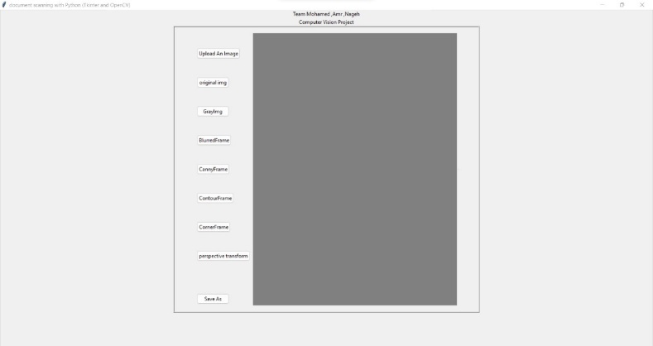

**OBJECTIVES :**

The main objectives of this application are:

1. To develop a scanner application that scans the image and text documents using the web camera and its features.

2. To deliver better scanned images and documents.

3. To minimize additional amounts of storage and focus on the

exact content mentioned by the user.

4. To provide authenticity and reliability.

5. To create backups and avoid interruption.

**METHODOLOGY :**

Document scanner scans the image and text documents using the web camera and deliver better scanned images and documents which can be further utilized by as per the need and demand. Document Scanner App is developed using python and its libraries. The working of doc scanner involves following steps and ways:

a). Select Image.

b). Scan the Image c). Save the Scanned Image

d). Recognize Text e). Save the Output Text a). Select Image: We use a GUI based image selection option. It will direct the user to a dialog box which will show the file explorer of the system from where the image can be selected manually. This option is very handy to use.

b). Scan the Image: This step involves the scanning of image which further involves three sub steps. They are as follows:

• Edge Detection

• Finding Contours

• Perspective Transform Edge Detection: To detect the edge of image the canny edge detector algorithm is used. The canny edge detector algorithm was developed in 1986 by John F. Canny. The Canny edge detection algorithm is composed of 5 steps:

1). Noise reduction

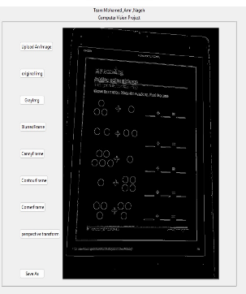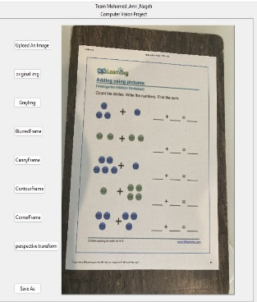

**Finding Contours:-**

A contour is a closed curve joining all the continuous points having some color or intensity, they represent the shapes of objects found in an image. Contour detection is a useful technique for shape analysis and object detection and recognition. For a better accuracy, here is the whole pipeline that we gonna follow to successfully detect contours in an image: • Convert the image to a binary image, it is a common practice for the input image to be a binary image (which should be a result of a thresholded image or edge detection). • Finding the contours using find Contours() OpenCV function. • Draw these contours and show the image. After applying these steps, you will be able to get the following

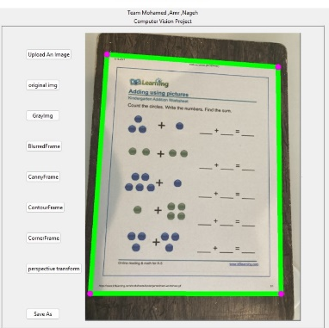

**Perspective Transform :**

The Perspective Transformation is that operation that we use when we want to change the perspective of an object. How to do perspective transformation?

• First we need to load the image we want to transform

• We then need to select 4 points, in order: top-left, top-right, bottom-left, bottom-right.

• Then drawing a circle to show the exact points we are taking.

create a list with this 4 points, and we’ll use this list later to apply the transformation

• create a new set of 4 points. This 4 points are the size of the new window where we want to display the image transformed.

• Then we apply the perspective transform to create the matrix and finally we can warp the image into using the original frame and the matrix just created.

• Then we can show it on the screen. After applying these steps, you will be able to get the following

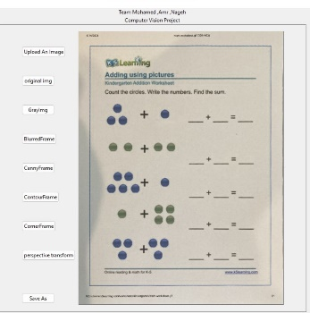

c). Save the Scanned Image: This step is concerned with the saving of the scanned image which can be used ahead for the further task. The image is stored in a particular format such as png or jpg.

FLOWCHART :

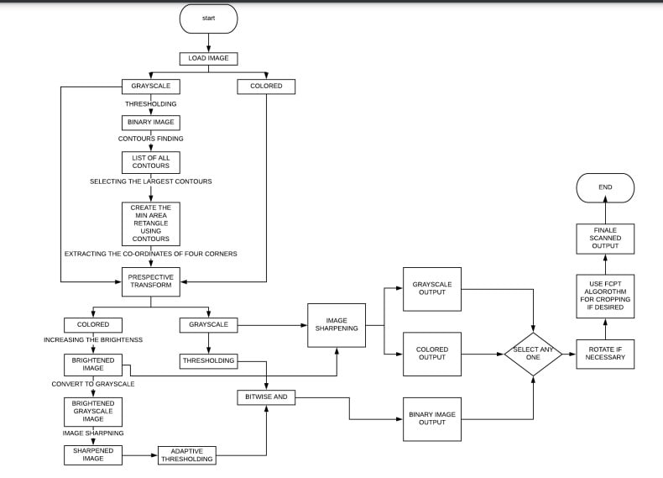

**CONCLUSION :**

The Doc Scanner App implemented using python fully meets the objectives for which it has been developed. It operates at a high level of accuracy and the user associated with the system understands its advantage. It was intended to solve the problem as per requirement specification and does this successfully by saving a lot of time, manual effort and extra expenses. Moreover, it makes the task of sharing and uploading documents easier and faster

**References**

[1] G. T. Shrivakshan and Dr. C. Chandrasekar, "A Comparison of various Edge Detection Techniques used in Image Processing", International Journal of Computer Science Issues, Vol. 9, Issue 5, No 1, September 2012.

[2] WenshuoGao , et.al. ; “An improved Sobel edge detection”, Computer Science and Information Technology (ICCSIT), 2010 3rd IEEE International Conference, China, Volume: 5 , pp. 67 – 71, 9-11 July 2010.

[3] Bao , P., Zhang, L., Wu, X.: Canny Edge Detection Enhancement by Scale Multiplication. IEEE Trans. on PAMI 27(9), 1485–1490 (2005)